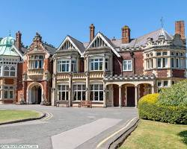
Bletchley Park, Buckinghamshire, England

What was the role of Bletchley Park in World War II?
During the Second World War, the estate housed the British Government Code and Cypher School (GC&CS), which regularly penetrated the secret communications of the Axis Powers
The key people who worked at Bletchley Park?
Alan Turing:
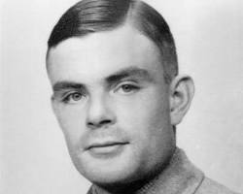

Dilly Knox:
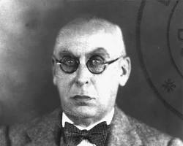
What were the working conditions like at Bletchley Park?
They were both intense, highly focused and secretly
What was the impact of Bletchley Park on the war?
Massively as it was used to decipher the enigma code messages allowing the allied forces to be a step ahead of the axis powers

What happened to Bletchley Park after the war?
It was eventually opened up to the public under a trust as a museum and attraction to show the importance of this team and how crucial it was for the war effort

What are some of the challenges that the codebreakers at Bletchley Park faced?

It required constant adaptation, it had to be completely hidden with no information leaks to avoid counter measures being deployed as well as the overwhelming pressure of this being needed to help with the success of the war effort
How did the codebreakers at Bletchley Park overcome these challenges?
Hardwork, Dedication, constant adaptation and continued use of advanced technologies.

What are some of the ethical considerations of codebreaking?
In war the ethical consideration was over privacy rights and the need for intelligence and security

What was the Enigma machine?

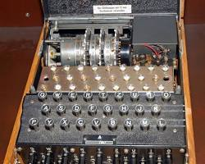
The enigma machine was a machine that was used to decipher Nazi code that was encoded with secret messages, which in the end helped protect the allied forces and help with the war effort

What was the Hut 6 at the complex used for?
Hut 6 was a wartime section of the Government Code and Cypher School
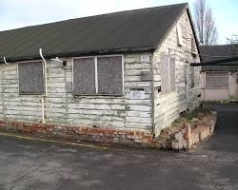

What was the Colossus computer?

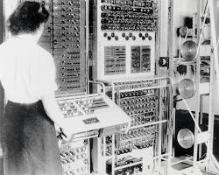

Colossus was a set of computers developed by British codebreakers in the years 1943–1945 to help in the cryptanalysis of the Lorenz cipher

What happened to Bletchley Park after the war?
It was eventually opened up to the public under a trust as a museum and attraction to show the importance of this team and how crucial it was for the war effort

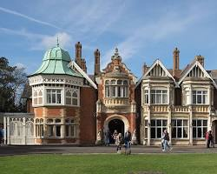

Women played a crucial role in the success of Bletchley Park, the top-secret British codebreaking establishment during World War II. While their contributions were largely kept under wraps for decades, their significance in breaking the Enigma code, a sophisticated encryption device used by the German military, is now widely recognised.
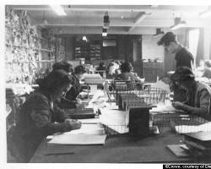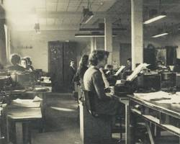

Research the women in the list below.

Joan Clark
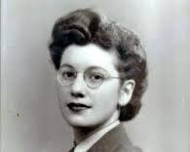
Code and Cypher School, which aimed to break the Enigma Code. Clarke's work involved the use of Banburismus, a statistical attack method that reduced the reliance on the more complex and time-consuming bombes

Mavis Batey
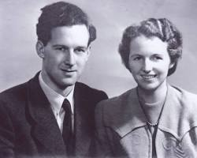
When Mavis picked up the test message, she noticed that there wasn't a single 'L' in it. Knowing that one of the weaknesses of the Enigma was that a letter could never be encoded into itself, she concluded that the operator had repeatedly been pressing the rightmost key on the bottom row.

Jean Valentine
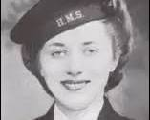
She was one of the operators of the Bombe decryption device in Hut 11 at Bletchley Park, which was designed by Alan Turing and others. Valentine was a member of the Women's Royal Naval Service (WRNS) and was recruited to work at Bletchley Park at the age of 18. Her work involved decrypting Japanese codes and she was later posted to Ceylon (now Sri Lanka) where she worked on Japanese meteorological reports.

Betty Webb
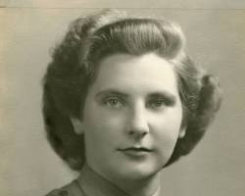

Betty Webb's role at Bletchley Park was crucial in the successful decoding of the German Enigma cipher. She was responsible for cataloguing and organizing intercepted German radio messages, which were then used to decipher the messages. Webb's work was part of a larger effort to break the Enigma, which was considered unbreakable by the Germans.

